Managing Emotions – Anger, Sadness, Anxiety, and Silliness – A Preventative Emotional Education Curriculum Unit
Alyssa Garrity
North Carolina State University

Appendix Index
Appendix A – Managing Emotions Parental Consent Form
Appendix B – Student Pre- and Post-Test Emotional Recognition Assessment
Appendix C – Lesson One: Iceberg Icebreaker Worksheet
Appendix D – Lesson Two: Where I feel Anger Worksheet & Anger Thermometer Worksheet
Appendix E – Lesson Three: Sadness Raincloud Worksheet & Positive Self-Talk Flower Activity
Appendix F – Lesson Four: What Anxiety Looks Like Poster, Moving Breathing Image, & 5-4-3-2-1 Grounding Exercise
Appendix G – Lesson Five: Calm Down Tools Mini Book & Managing Emotions Poster
Appendix H – Bibliography for Managing Emotions
Appendix I – Digital Media for Managing Emotions
Appendix J – Student, Teacher, & Principal Program Satisfaction Survey’s

Introduction to Managing Emotions
Managing Emotions is a five-lesson preventative tertiary curriculum unit that is designed to reduce high numbers of discipline referrals while increasing student emotional recognition and coping skills. Students in third through fifth grades, who have received more than one discipline referral in a month’s time during the current school year, will be invited into the Managing Emotions program. With parent permission (see appendix A), these students will have an environment to productively work on self-regulatory intrapersonal emotions that will increase student emotional awareness and coping skill knowledge. Moreover, due to the projected decrease in student discipline referrals, Managing Emotions is also projected to cause a raise in teacher and principal morale. Thus, creating a productive academic environment in which all can learn and grow.
In small groups of five, students will complete five sessions of the Managing Emotions curriculum unit. These bi-weekly sessions will last for forty-five minutes each. Each lesson is uniquely designed to enhance recognition of emotion and promote new coping skills. Lesson one – Recognizing Emotions – will introduce the unit and encourage students to think critically on the many emotions they experience and how that effects their outward perceptions. Lesson two – Recognizing Anger – will focus on the physical symptoms of anger and introduce new coping skills that students can use in-the-moment when their anger gets out-of-control. Lesson three – Recognizing Sadness – will emphasize the need to ask for help during emotionally strained times. Students will also be given the opportunity to become familiarized with positive self-talk. Lesson four – Recognizing Anxiety – will bring students’ attention to the power worry can physically have on their bodies. Students will openly discuss anxiety driven situations and become introduced to the power of deep-breathing and physical grounding. Lesson five – Recognizing Silliness – will end the Managing Emotions unit by focusing on strategies to calm down when focusing in class and following directions seems too difficult. Additionally, students will discuss what it means to be a leader at school and the obligation they have to the school community to practice emotional self-control.
Research
Research supports this emotionally focused tertiary prevention program as a constructive way to decrease discipline referrals, increase student emotional intelligence, and grow the overall school morale. Sherrod and Getch state in their article, that
“the premise that as students' knowledge, attitudes, and skills increase, their behavior
improves. As the behavior of the students improves, the teacher's perception ratings
improve. Therefore, the decreased number of post-intervention (discipline) referrals may be attributed to the knowledge gained by the students' involvement in the group and the positive perceptions of the teachers” (2009).
Consequently, focusing on positive behavior and coping skills versus punishment for past
behavior referrals will be key to the success of the program. In this way, students can grow socially and emotionally and therefore advance academically. Hendley and Lock (2007) further explain that the goal should not be to increase punishment hoping for a decrease in discipline referrals, but to develop effective programs built on challenging difficult behavior and re-learning social skills so positive social and academic development can occur.
However, to advance in these areas, the targeted program must be effective. Hawken (2006) posits that “The crucial elements of targeted interventions are that they are efficient (i.e., students receive support shortly after being identified) and cost effective to implement” (p. 93). As seen in the lesson plans below, the materials needed for all Managing Emotions lessons are relatively few, thus being a financially cost-effective program. Due to the lessons being under an hour, Managing Emotions is also considerate of students’ time.
Additional research supports the use of small group counseling with elementary school students. For example, “group and behavior therapy that focused on targeted behaviors and problem- solving abilities was effective” (Brantley, Brantley, & Baer-Barkley, 1996). Thus, to reduce group size and prevent bad behavior “bragging”, five small groups of five students will meet bi-weekly for the duration of the counseling program. Hutchinson and Pretelt also discuss the importance in using small groups to enhance student emotional growth by saying
“Goal directed problem focused coping efforts directed at solving or managing a problem through identifying realistic goals, internal resources and small acts of mastery over the difficult situation —happens within a social context so that these positive emotions can ‘resound through others’ (Fredrickson, 2003) transforming not only the children but their families and school communities as well” (2010, p.22).
Therefore, by focusing on positive ways students can practice self-control and coping skills, Managing Emotions will use the power of small group therapy to create a residual effect that permeates throughout the school.

Managing Emotions: Lesson Plan – Lesson One
Title: Recognizing Emotions
Audience: Small group of five students pre-identified for the Managing Emotions program in grades 3-5
Objective: To introduce the curriculum unit Managing Emotions. Students will be given a pre-program knowledge check that assess their current emotional recognition and coping skills. Students will examine what different feelings look like internally and externally.
Materials/ Resources:
- Pre-program knowledge check handout (See Appendix B)
- Iceberg Icebreaker activity (See Appendix C Figure 1)
- Colored Pencils
- “Today I Feel Silly: And Other Moods That Make My Day” book by Jamie Lee Curtis (See Appendix H)
Process Data: Students with more than one referral in a months’ time will from grades 3-5 will participate in five bi-weekly small group counseling sessions. The number of small groups are determined by the number of students with more than one referral in a months’ time, as well as parent permission.
Perception Data: Pre-program principal discipline referral opinion survey. Pre-program teacher discipline referral opinion survey. Pre-program student emotional knowledge check.
Outcome Data: A projected 40% reduction in discipline referrals from students participating in the program. This will be assessed by pulling school discipline referral queries in the school computer system. A projected 90% increase in student emotional knowledge and coping skills. This will be assessed through pre- and post-student knowledge checks. A 50% increase in teacher satisfaction of student behavior. This will be assessed through pre- and post-teacher opinion surveys. A 50% increase in principal satisfaction of student behavior. This will be assessed through pre- and post-teacher opinion surveys.
Activity: Small Group - 45 Minutes
- Counselor will lead the discussion on the importance of recognizing emotions.
- Counselor will read the book “Today I feel Silly: And Other Moods That Make My Day” by Jamie Lee Curtis.
- Counselor will pass out the Icebreaker Iceberg activity where students will fill out what other people can visibly see about them (the tip of the iceberg) and identify hidden emotions of what people cannot see (the bottom of the iceberg under the water).
- Students and counselor will discuss why recognizing these hidden emotions are important for overall mental health and self-control. Students will identify how it makes them feel to have hidden emotions.

Lesson 1

Managing Emotions: Lesson Plan – Lesson Two
Title: Recognizing Anger
Audience: Small group of five students pre-identified for the Managing Emotions program in grades 3-5
Objective: To introduce the physical feelings of Anger. Students will examine what areas of their body they feel anger and contemplate ways to go from a “hot moment” to a “cool calm”.
Materials/ Resources:
- Grumpy as a Grizzly Bear – Storybots Youtube Video (See Appendix I)
- Where I feel anger worksheet (See Appendix D Figure 2)
- “When I feel Angry” book by Cornelia Maude Spelman (See Appendix H)
- Anger thermometer worksheet (See Appendix D Figure 3)
- Coloring Pencils
Process Data: Students with more than one referral in a months’ time will from grades 3-5 will participate in five bi-weekly small group counseling sessions. The number of small groups are determined by the number of students with more than one referral in a months’ time, as well as parent permission.
Perception Data: Pre-program principal discipline referral opinion survey. Pre-program teacher discipline referral opinion survey. Pre-program student emotional knowledge check.
Outcome Data: A projected 40% reduction in discipline referrals from students participating in the program. This will be assessed by pulling school discipline referral queries in the school computer system. A projected 90% increase in student emotional knowledge and coping skills. This will be assessed through pre- and post-student knowledge checks. A 50% increase in teacher satisfaction of student behavior. This will be assessed through pre- and post-teacher opinion surveys. A 50% increase in principal satisfaction of student behavior. This will be assessed through pre- and post-teacher opinion surveys.
Activity – Small Group 45 Minutes
- Students will watch the short video/song “Grumpy as a Grizzly Bear” by Storybots. A class discussion will be facilitated about what anger looked like in the video.
- The “Where I feel Anger” worksheet will be passed to each student. Students will be asked to think of a time when they were very angry and color in the parts of their body that felt “hot” and angry.
- The counselor will read the book “When I feel Angry” by Cornelia Maude Spelman. A group discussion will consist of situations where students feel angry and the different things they can do to calm down.
- The “Anger Thermometer” worksheet will be passed to each student. Students will be asked to color in the thermometer and identify situations in which they get angry (on the left). Students will also fill in ways they can calm down (on the right).

Lesson 2
Managing Emotions: Lesson Plan – Lesson Three
Title: Recognizing Sadness
Audience: Small group of five students pre-identified for the Managing Emotions program in grades 3-5
Objective: To introduce the different ways that sadness manifests itself. Students will examine what “shades” of sadness they have experienced and what types of situations make them sad. Students will begin thinking about ways positive self-talk and how positive self-esteem can defeat sadness.
Materials/ Resources:
- Sadness Raincloud Worksheet (See Appendix E Figure 4)
- “Feelin’ Sad and Blue” – Storybots Youtube Video (See Appendix I)
- “When I feel Sad” book by Cornelia Maude Spearman (See Appendix H)
- Positive self-talk flower activity printout (See Appendix E Figure 5)
- Colored Pencils
Process Data: Students with more than one referral in a months’ time will from grades 3-5 will participate in five bi-weekly small group counseling sessions. The number of small groups are determined by the number of students with more than one referral in a months’ time, as well as parent permission.
Perception Data: Pre-program principal discipline referral opinion survey. Pre-program teacher discipline referral opinion survey. Pre-program student emotional knowledge check.
Outcome Data: A projected 40% reduction in discipline referrals from students participating in the program. This will be assessed by pulling school discipline referral queries in the school computer system. A projected 90% increase in student emotional knowledge and coping skills. This will be assessed through pre- and post-student knowledge checks. A 50% increase in teacher satisfaction of student behavior. This will be assessed through pre- and post-teacher opinion surveys. A 50% increase in principal satisfaction of student behavior. This will be assessed through pre- and post-teacher opinion surveys.

Activity – Small group 45 Minutes
- Students will watch the short video/song “Feelin’ Sad and Blue” by Storybots. A short class discussion will be had on the different ways sadness looked in the video.
- Students will be given a sadness raincloud worksheet. Students will be asked to color the cloud the shade they believe sadness resembles. The counselor will lead a discussion on the different ways sadness can be shown.
- Students will fill in their raindrops with different things that make them sad and share their drops with the group.
- The counselor will read the book “When I feel sad” by Cornelia Maude Spearman. A group discussion will follow by discussing ways to defeat sadness.
- Students will complete the positive self-talk flower and discuss how sadness is inevitable, but through positivity, we can defeat that sadness and put it towards good use (empathy).

Lesson 3

Managing Emotions: Lesson Plan – Lesson Four
Title: Recognizing Anxiety
Audience: Small group of five students pre-identified for the Managing Emotions program in grades 3-5
Objective: To introduce the concept of anxiety and worry. Students will examine what anxiety and worry physically feel like. Students will be introduced to mindfulness such as deep breathing and grounding skills.
Materials/ Resources:
- What Anxiety Feels and Looks Like poster (See Appendix F figure 6)
- Dry erase markers
- “When I feel worried” book by Cornelia Maude Spelman (See Appendix H)
- Moving deep breathing image (See Appendix F figure 7)
- Grounding 5 4 3 2 1 activity printout (See Appendix F figure 8)
Process Data: Students with more than one referral in a months’ time will from grades 3-5 will participate in five bi-weekly small group counseling sessions. The number of small groups are determined by the number of students with more than one referral in a months’ time, as well as parent permission.
Perception Data: Pre-program principal discipline referral opinion survey. Pre-program teacher discipline referral opinion survey. Pre-program student emotional knowledge check.
Outcome Data: A projected 40% reduction in discipline referrals from students participating in the program. This will be assessed by pulling school discipline referral queries in the school computer system. A projected 90% increase in student emotional knowledge and coping skills. This will be assessed through pre- and post-student knowledge checks. A 50% increase in teacher satisfaction of student behavior. This will be assessed through pre- and post-teacher opinion surveys. A 50% increase in principal satisfaction of student behavior. This will be assessed through pre- and post-teacher opinion surveys.
Activity – Small Group 45 Minutes
- Students will come up to the front of the classroom and circle with a dry erase marker what ways they have felt physically anxious (worried) in the past on the What Anxiety Feels and Looks Like poster.
- Counselor will read the book “When I feel worried” by Cornelia Maude Spelman.
- The counselor will facilitate a group discussion about the kinds of situations that made the protagonist anxious in the book and the different situations that make the students feel anxious.
- The counselor will introduce the idea of mindfulness with an example of deep breathing using a moving breathing image.
- The counselor will then have the students complete the grounding 5 4 3 2 1 activity and discuss how it made them afterwards.

Lesson 4

Managing Emotions: Lesson Plan - Lesson Five
Title: Recognizing Silliness
Audience: Small group of five students pre-identified for the Managing Emotions program in grades 3-5
Objective: Students will discuss what silliness looks, sounds, and feels like. The counselor will facilitate a discussion on the responsibility the Managing Emotions students have to be calm during class time. Students will review calming down skills they have learned and generate new ideas for calming down. Finally, students will become leaders in the school by having high emotional intelligence. Students will be given a post-program knowledge check to assess emotional recognition and coping skills. Students will be given a short opinion survey on the Managing Emotions program.
Materials/ Resources:
- “When I’m Silly” Song/Video by Storybots on Youtube (See Appendix I)
- Calm Down Tools Mini book printouts (See Appendix G figure 9)
- Managing Emotions Poster (See Appendix G figure 10)
- Wall-safe tape
- Post-Program assessments and surveys
Process Data: Students with more than one referral in a months’ time will from grades 3-5 will participate in five bi-weekly small group counseling sessions. The number of small groups are determined by the number of students with more than one referral in a months’ time, as well as parent permission.
Perception Data: Pre-program principal discipline referral opinion survey. Pre-program teacher discipline referral opinion survey. Pre-program student emotional knowledge check.
Outcome Data: A projected 40% reduction in discipline referrals from students participating in the program. This will be assessed by pulling school discipline referral queries in the school computer system. A projected 90% increase in student emotional knowledge and coping skills. This will be assessed through pre- and post-student knowledge checks. A 50% increase in teacher satisfaction of student behavior. This will be assessed through pre- and post-teacher opinion surveys. A 50% increase in principal satisfaction of student behavior. This will be assessed through pre- and post-teacher opinion surveys.
Activity – Small Group 45 Minutes
- Students will watch “When I’m Silly” by Storybots and discuss times when they themselves have felt silly.
- Students will be introduced to the idea of inappropriate silliness. The counselor will facilitate a discussion on the responsibility Managing Emotion students have to their teachers and peers to stay on task and effectively calm themselves down.
- Each student will receive a Managing Emotions Poster and will brainstorm helpful ideas on where to hang the poster in the school
- Students will be given post-program assessments and surveys

Lesson 5

Closing-the-Gap Goal in SMART Goal Format

By |  | End of the School Year |  | , | Students in grades 3-5 with 2+ discipline referrals occurring in a month’s span
 |  | End Date |  |  | Targeted Group
will |  | Increase student knowledge of emotions, self-calming and coping, and self-management skills. Decrease student discipline referrals.
 |  | Increase/Decrease Something related to Achievement, Attendance, or Behavior
by | Attending the bi-weekly five week Managing Emotions School Counselor Program
 |  | Measure of Change
from |  |  | 2+ discipline referrals in a month |  |  | to | >1 discipline referrals in a month
 |  | Baseline Data |  |  |  |  | Target Data

Identify outcome data (attendance, achievement, or behavior) supporting need for this goal:
Behavior (discipline referral) data will be measured using the school system referral
database. Discipline referrals are projected to decrease by 40%. Student program knowledge will
be measured with the use of pre- and post-program knowledge checkpoint quizzes. Student knowledge is expected to increase by 90%.

Identify supporting perception data to further understand this goal:
Student, teacher, and principal program satisfaction will be measured with surveys.
Student pre-and post- assessments will be given to measure student perception of emotional
recognition and coping skills.

Identify any possible systemic issues related to this goal:
Getting students out of class at the same time without interrupting learning. Having students
Connection emotionally across grade levels. Attaining parental permission forms in time for the
program to begin. Possible bad “bragging” behavior when in a group setting (bad apple scenario).

Identify programs/activities currently employed to address this goal:
School motto
Counselor emotion posters

Identify possible counselor interventions/strategies to address this goal:
Five weeks long (bi-weekly / 45 minute) program entitled Managing Emotions in which
students are given the opportunity to learn about emotion recognition, coping skills, community
resources, and personal responsibility.

Managing Emotions
American School Counseling Association (ASCA) Standards and Mindsets:

Academic Development:
A:A2.3 Use communications skills to know when and how to ask for help when needed A:A3.1 Take responsibility for their actions
A:B1.4 Seek information and support from faculty, staff, family and peers
Career Development:
C:C2.2 Learn how to use conflict management skills with peers and adults Personal/Social Development:
PS:A1.2 Identify values, attitudes and beliefs
PS:A1.5 Identify and express feelings
PS:A1.10 Identify personal strengths and assets
PS:B1.1 Use a decision-making and problem-solving model
PS:B1.2 Understand consequences of decisions and choices
PS:B1.3 Identify alternative solutions to a problem
PS:B1.4 Develop effective coping skills for dealing with problems
PS:B1.5 Demonstrate when, where and how to seek help for solving problems and making decisions
PS:B1.6 Know how to apply conflict resolution skills
PS:B1.8 Know when peer pressure is influencing a decision
PS:C1.9 Learn how to cope with peer pressure

(American School Counselor Association, 2014)
Lessons 1 - 5
Evaluation and Using Data
According to the American School Counselor Association (ASCA) National Model (2012), school counselors must use data in their counseling programs as a way to stay accountable and “to monitor student achievement, to continually evaluate and improve their school counseling program and to demonstrate the impact their program is having on students” (p. 99). By pulling student discipline referral data from the school computer system, the counselor will be able to first, identify students who have more than one discipline referral in a month’s time. Secondly, the counselor will be able to monitor student discipline referrals as the program is ongoing, and after its completion. This data is a valuable tool the school counselor must utilize to examine program strengths and weakness.
Students, teachers, and principals will also be surveyed to evaluate the perception data surrounding Managing Emotions program satisfaction (see Appendix J). These self-measured reports will be useful for the counselor to determine the program’s popularity and overall school morale post-program. By gaining this knowledge, the counselor can adjust future implementations of the program and accurately assess how to report findings.
Sharing Results
Sharing the results of the Managing Emotions program is a key component to future implementations. ASCA (2012) states that
“regularly sharing results reports about the impact of the school counseling program with administrations, faculty and the school community in a document or in a five- to 10-minute presentation will likely promote understanding, increase the value of and promote respect and indispensability for the work of professional school counselors” (p. 104).
As one of the goals of Managing Emotions is to increase the overall school morale, sharing the results of the program is integral in promoting an overall positive discipline atmosphere within the school that facilitates higher levels of emotional intelligence and thus, improved academic achievement.

References
American School Counselor Association (2014). ASCA Mindsets & Behaviors for Student Success. Retrieved April 19, 2018, from https://www.schoolcounselor.org/asca/media/asca/home/MindsetsBehaviors.pdf
American School Counselor Association (2012). The ASCA National Model: A Framework for School Counseling Programs, Third Edition. Alexandria, VA: Author.
Brantley, L. S., Brantley, P. S., & Baer-Barkley, K. (1996). Transforming acting-out behavior: A group counseling program for inner-city elementary school pupils. Elementary School Guidance & Counseling, 31(2), 96-105.
Breathing Gif [Digital image]. (n.d.). Retrieved April 19, 2018, from https://media.giphy.com/media/krP2NRkLqnKEg/giphy.gif
Burnett, C. (2017, August 24). 5 Steps to Managing Big Emotions: Printable. Retrieved April 19, 2018, from https://childhood101.com/helping-children-manage-big-emotions/
Chiavarone, K. (2017, April 03). 8 Ways Kids Can Calm Down Anywhere PLUS a Printable Mini Book. Retrieved April 19, 2018, from http://themommyview.viewsfromastepstool.com/index.php/2017/04/03/calm-down-anywhere/
Cordes, Stephanie. (n.d.) 5-4-3-2-1 Grounding Exercise. Http://Www.drcordes.com/static1.squarespace.com/static/530782c6e4b05512e6e90a18/t/56d06ceb37013b97b19f7c21/1456499947764/54321 Grounding Exercise.pdf
Curtis, J. L. (2007). Today I Feel Silly & Other Moods That Make My Day. New York: Joanna Cotler Books.
Hawken, L. S. (2006). School psychologists as leaders in the implementation of a targeted intervention: The Behavior Education Program. School Psychology Quarterly, 21(1), 91-111. doi:10.1521/scpq.2006.21.1.91
Hendley, S. L., & Lock, R. H. (2007). Use positive behavior support for inclusion in the general education classroom. Intervention in School and Clinic, 42, 225-228.
Hutchinson, J., & Pretelt, V. (2010). Building resources and resilience: Why we should think about positive emotions when working with children, their families and their schools. Counselling Psychology Review, 25(1), 20-27.
My Anger Thermometer [Digital image]. (n.d.). Retrieved April 19, 2018, from https://copingskillsforkids.com/blog/2016/4/27/making-a-feelings-thermometer
Rex, M. (2015, February 21). Recent Additions. Retrieved April 19, 2018, from http://www.elementaryschoolcounseling.org/marissas-blog/recent-additions
Sherrod, M. D., Getch, Y. Q., & Ziomek-Daigle, J. (2009). The impact of positive behavior support to decrease discipline referrals with elementary students. Professional School Counseling, 12(6), 421-427. doi:10.5330/PSC.n.2010-12.421
Spelman, C. (2000). When I Feel Angry. Morton Grove, IL: A. Whitman & Company.
Spelman, C. (2002). When I Feel Sad. Morton Grove, IL: A. Whitman & Company.
Spelman, C. (2013). When I Feel Worried. Chicago, IL: A. Whitman & Company.
[StoryBots]. (2014, April 21). “Feelin’ Sad and Blue,” Songs About Emotions” [Video File]. Retrieved from https://www.youtube.com/watch?v=ZctmpqIu1Zs
[StoryBots]. (2014, September 22). “Grumpy as a Grizzly Bear,” Songs about Emotions [Video File]. Retrieved from https://www.youtube.com/watch?v=2sGrSFa15eA
[StoryBots]. (2014, April 7). “When I’m Silly,” Songs About Emotions [Video File]. Retrieved from https://www.youtube.com/watch?v=6rWbj0y-S-A
What Anxiety Feels and Looks Like [Digital image]. (n.d.). Retrieved April 19, 2018, from https://i.pinimg.com/originals/aa/ea/09/aaea092ec298c46fba8d5087e7f6477f.jpg
Where I Feel Anger [Digital image]. (n.d.). Retrieved April 19, 2018, from http://theanxietyguru.org/teen-anxiety-attacks-signs-symptoms-and-remedies/

Appendix A
Managing Emotions Parental Consent Form

_________ Elementary School
ADDRESS
CITY/STATE/ZIP
PHONE/FAX NUMBER
Managing Emotions Counseling Program
Dear Parent(s)/Guardian(s):

Your child _______________ qualified for a special small group counseling service entitled Managing Emotions at school. This program is designed for students who are receiving multiple discipline referrals in the school year. Managing Emotions will cover emotional recognition and coping skills that your child may use inside and outside of the classroom. We appreciate any consideration you may give to this type of assistance for your child. If you would like your child to receive these counseling services, please complete, sign and return the enclosed papers to school.
The following are explanations of each form provided:

Parental Informed Consent: This form allows your child to participate in counseling.

I always enjoy hearing from parents. Please call me with any questions, concerns, or progress that you may wish to hear about or report.

Sincerely,
Alyssa Garrity
School Counselor
_________ Elementary School
(School Phone Number
(School Email Address) Page 1 of 2

Parent Informed Consent for Elementary Counseling Services

Child’s Name: _______________ ____________________ ___________________

I, the undersigned, ______________________________________________ am fully aware of all the circumstances of my son’s/daughter’s participation in counseling services and I give the school my informed consent to provide these services.

________________________________________ ____________________________
Parent Signature Date

Information will be treated confidentially.
Confidentiality shall NOT be maintained where there is:
- Reason to suspect the occurrence of child abuse or neglect
- Where there is clear threat to do serious bodily harm to self and/or others
- Where a court intervenes under court order

Page 2 of 2

Appendix B
Student pre- and post-test emotional recognition assessment
Emotion Recognition Survey
Note: 0=Not at all; 1=Very little; 2= Somewhat; 3=Quite a bit; 4= Very much
- When I feel angry, I understand why 0 1 2 3 4

- When I feel sad, I understand why 0 1 2 3 4

- When I feel anxious (worried), I understand why 0 1 2 3 4

- When I feel silly, I understand why 0 1 2 3 4

I can calm myself down by: (list the ways that you know to calm yourself down)

- When I get in trouble at school, it is because my teachers just do not understand how I feel
0 1 2 3 4
2- I understand what my emotions look like to my peers and teachers
0 1 2 3 4
3- I feel in control of myself during emotional moments
0 1 2 3 4


Appendix C
Lesson One – Recognizing Emotions
Figure 1. Iceberg Icebreaker Worksheet (Rex, 2015)
Appendix D
Lesson Two – Recognizing Anger
Figure 2. Where I feel Anger Worksheet (Where I feel Anger, n.d.)
& Figure 3. Anger Thermometer Worksheet (My Anger Thermometer, n.d.)
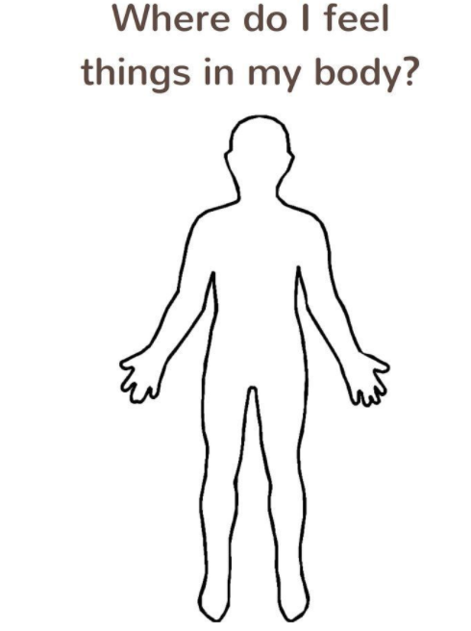
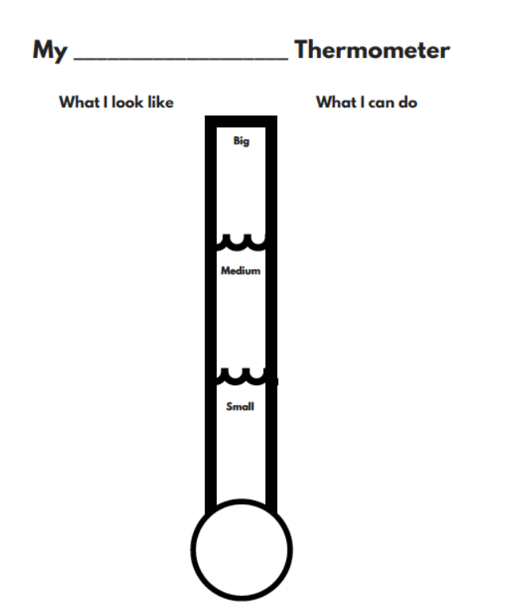

Appendix E
Lesson 3 – Recognizing Sadness
Figure 4. Sadness Raincloud Worksheet

Name: __________________________________________________

Directions: Color your raincloud the color you feel when you are sad. Write in raindrops the things that make you sad.

Figure 5. Positive Self-Talk Flower Activity

My Positive Self-Talk Flower
Directions: Fill in the petals with positive self-talk you can use during difficult moments. Cut out the flower when you are done and use the flower when you need it the most.


My Positive Self-Talk

Appendix F
Lesson 4 – Recognizing Anxiety
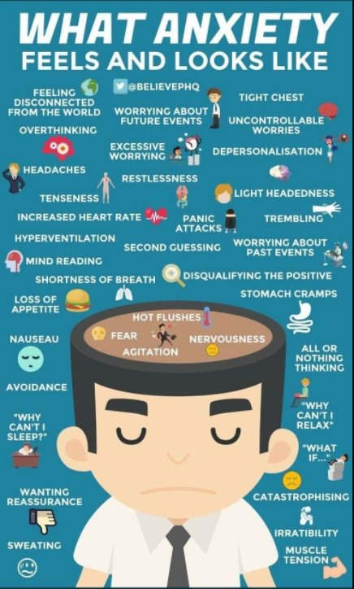
Figure 6. What Anxiety Feels and Looks Like Poster (What Anxiety Feels and Looks Like, n.d.)

Figure 7. Moving Breathing Image (Breathing Gif, n.d.) &
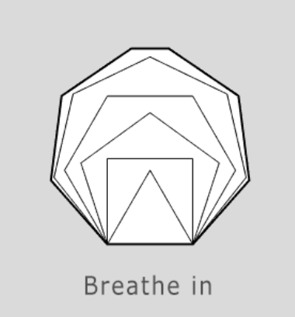

Figure 8. Grounding 5 4 3 2 1 Activity (Cordes, n.d.)
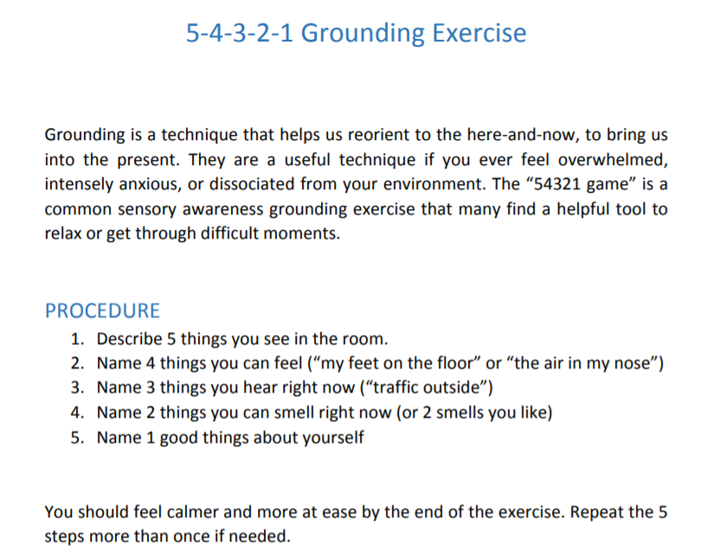

Appendix G
Lesson 5 – Recognizing Silliness
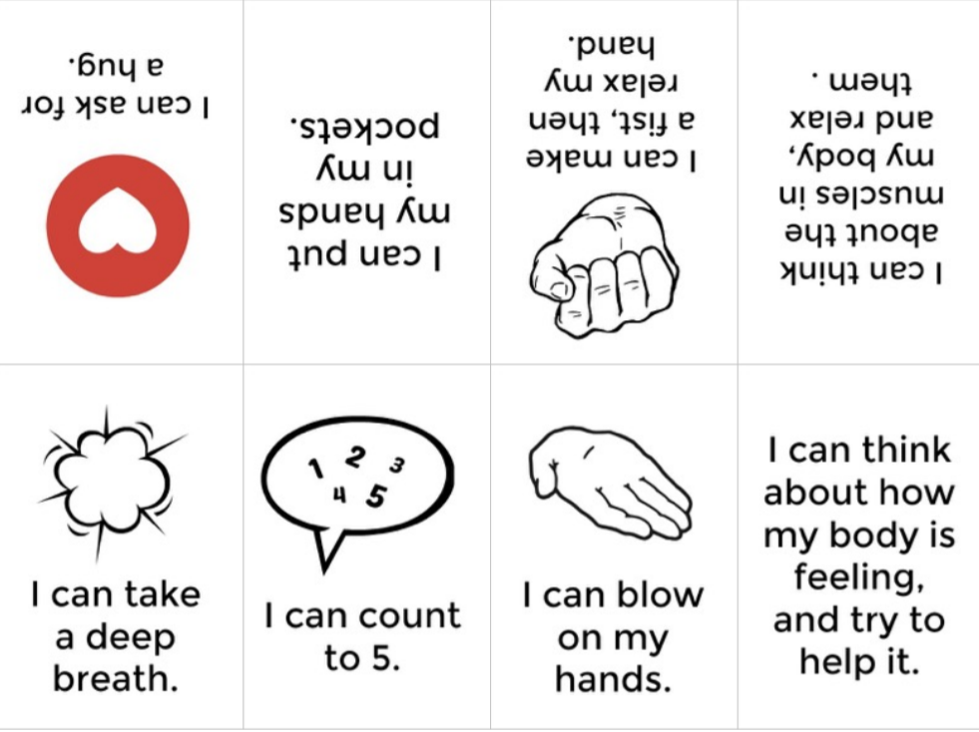
Figure 9. Calm Down Tools Mini Book (Chiavarone, 2017)

Figure 10. Managing Emotions Poster (Burnett, 2017)

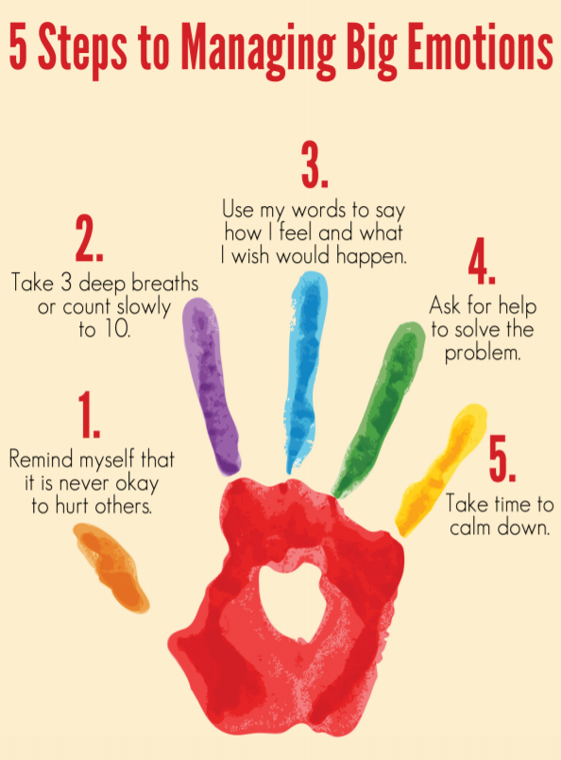

Appendix H
Bibliotherapy for Managing Emotions
Lesson One – Recognizing Emotions
Today I feel Silly & Other Moods That Make My Day by Jamie Lee Curtis
ISBN: 0060245603
(Curtis, 2007)
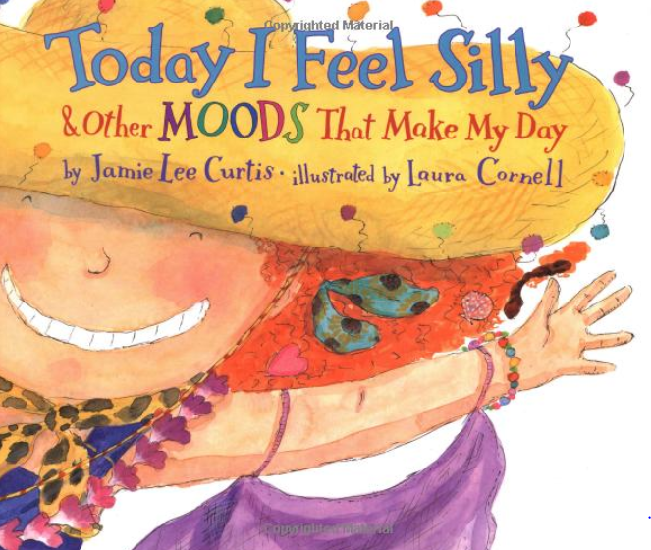
Lesson Two – Recognizing Anger
When I Feel Angry by Cornelia Maude Spelman
ISBN: 0-8075-8888-1
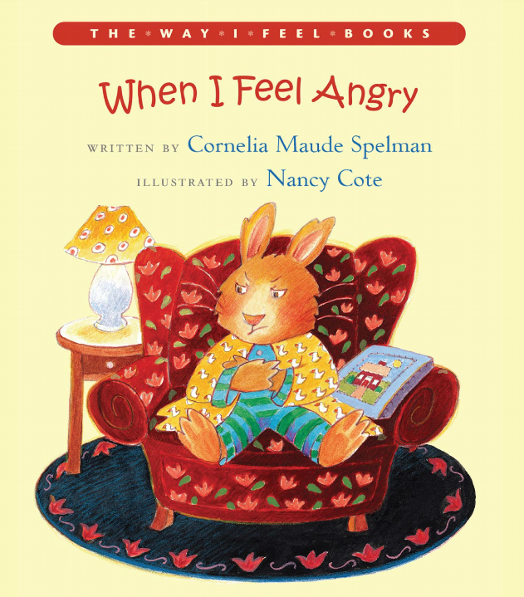
(Spelman, 2000)

Lesson Three – Recognizing Sadness
When I Feel Sad by Cornelia Maude Spelman
ISBN: 0-8075-8891-1
(Spelman, 2002)
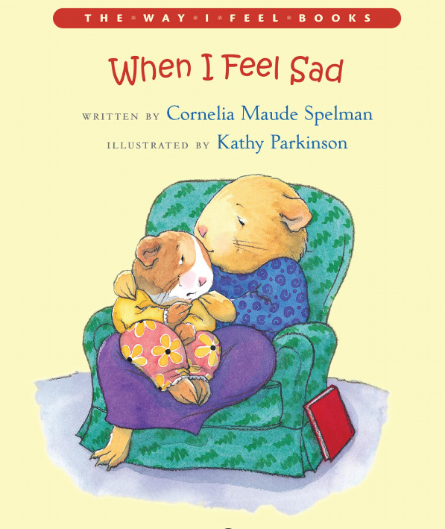

Lesson Four – Recognizing Anxiety
When I feel Worried by Cornelia Maude Spelman
ISBN: 978-0-8075-8893-2
(Spelman, 2013)
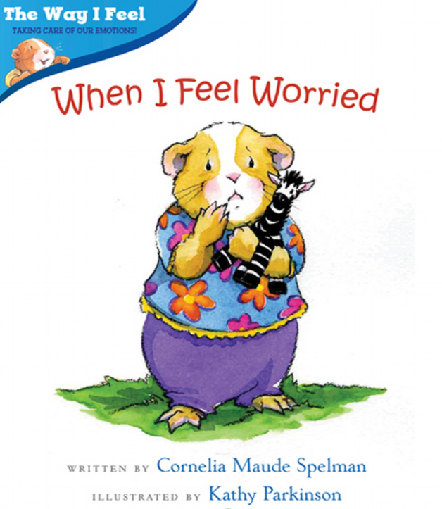

Appendix I
Digital Media for Managing Emotions
Lesson Two- Recognizing Anger
“Grumpy as a Grizzly Bear,” Songs About Emotions – by StoryBots
https://www.youtube.com/watch?v=2sGrSFa15eA
(StoryBots, 2014)
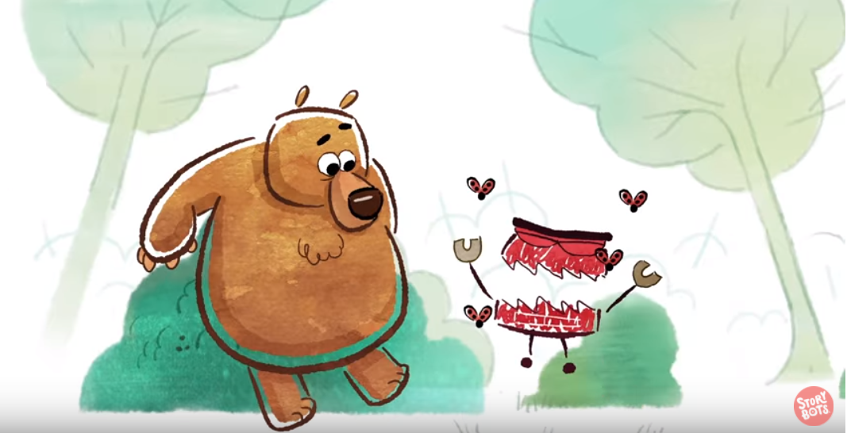

Lesson Three- Recognizing Sadness
“Feelin’ Sad and Blue,” Songs About Emotions – by StoryBots
https://www.youtube.com/watch?v=ZctmpqIu1Zs
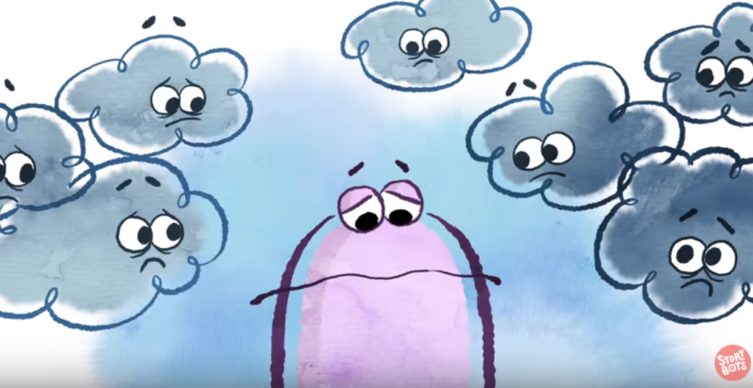
(StoryBots, 2014)

Lesson Five – Recognizing Silliness
“When I’m Silly,” Songs About Emotions – by StoryBots
https://www.youtube.com/watch?v=6rWbj0y-S-A
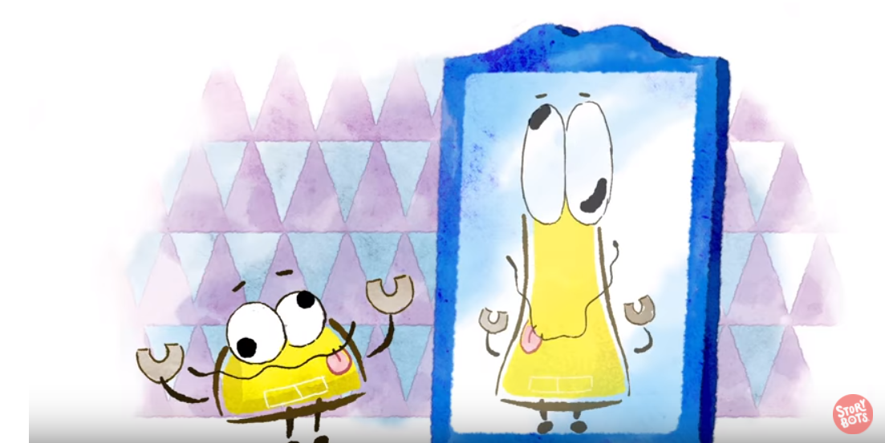
(StoryBots, 2014)

Appendix J
Post-Program Satisfaction Survey Examples
Principal Program Satisfaction Survey

1. I saw the program as beneficial 0 1 2 3 4
to the students in my school.

2. The students enjoyed 0 1 2 3 4
the group sessions.

3. There were reports of students' 0 1 2 3 4
behavioral improvement.

4. I would like similar sessions 0 1 2 3 4
for my school in the future.

5. The school counselor appeared 0 1 2 3 4
to be professional in their duties.

6. I feel more positively about the 0 1 2 3 4
rate of discipline referrals in the school

Note. 4 = strongly agree; 3 = agree; 2 = not sure; 1 = disagree; 0 = strongly disagree

Teacher Program Satisfaction Survey

1. I saw the program as beneficial 0 1 2 3 4
to the students in my classroom.

2. The students enjoyed 0 1 2 3 4
the group sessions.

3. I can see improvements in the 0 1 2 3 4
in the students' behavior.

4. I believe that similar programs in 0 1 2 3 4
the future will be beneficial to my students.

5. The school counselor appeared to be 0 1 2 3 4
professional in their duties.

6. I feel more positively about the 0 1 2 3 4
emotional behavior displayed in my classroom.

Note. 4 = strongly agree; 3 = agree; 2 = not sure; 1 = disagree; 0 = strongly disagree

Student Program Satisfaction Survey

1. Did you enjoy being in the group? 0 1 2 3 4

2. Did the group help you? 0 1 2 3 4

3. Did you learn new ways to manage emotions? 0 1 2 3 4

4. Were you able to help other members in the group? 0 1 2 3 4

5. Did you feel you could talk openly in the group? 0 1 2 3 4

6. Would you like to be in a group similar to this in the future? 0 1 2 3 4

Note. 4 = Yes, A lot; 3 = Yes, A little; 2 = Not sure; 1 = Sometimes; 0 = Not at all

